FONTS

* Ethnocentric
* Poppins

Information

* The SteelSeries and Ducky websites served as inspiration for this website.

Concept

* The website is for people who love video games and people who are keyboard enthusiasts.
* The age viewers are around 15-30 years old.

Uke 11 (Website Design/Layout Adobe XD)

Before

* Made a hero style design that matches the keyboard design.
* Questioned Jasan about the design and he wanted to fix the background because it looks plain hero style.

AFTER

* Changed the background and add a svg wave that makes the website looks better.

Before

After

* Under the Hero style is a shop category where when the customer hover the mouse to any custom button the picture next to it will zoom in and it will blur out after the mouse has been hovered.
* My teacher gave me some advice, telling me to focus on matching the colors in the photographs so the color scheme will appear well.

UKE 15

Dokumentasjon

Mandag

* Starte å lage en logo for nettside



* Fix noe code ved bruk av JavaScript og CSS
* Lage en bølge design ved bruk av <https://getwaves.io/>
* Gjorde brukertesting med Jasan om hva han syntes om logoen.
* Den var bra, lett å forstå

Tirsdag

* Fortsette å jobbe med Product_Nettside
* Spurte Jasan om hva han syntes om Product_Nettside

-han vil ha en hover hvor man kan få en bedre oversikt over Produckt.

Onsdag

* Arbeide med reference på bildet
* A screenshot of a computer

  Description automatically generatedSortere filen på riktig plass

* Arbeide med riktig størrelse på bildet

Torsdag

* Jobbe med «HoverPreview» på Hver Product
* Jobbe med JavaScript for å ha bedre design og animasjon.
* Spurte Tarald om JavaScript sturturen og han syntes at det er bra men trenger å ha variabler.

* Bruke JavaScript for å trene meg selv til å bli bedre på det

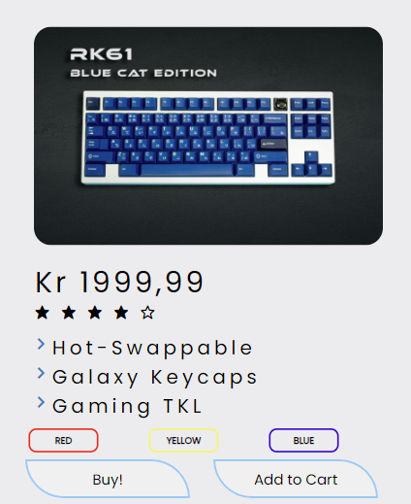Fredag

* Lagt en knapp med hover animasjon som er inspirert fra <https://uiverse.io/buttons>
* Gjorde brukertesting med Frendon om hva han syntes om HOVER KNAP.
* Den var bra animation, likte hover animation.

UKE 18

Dokumentasjon

Mon

* Før
* Strukturen mangler en “var” så fikset jeg det.
* Strukturen mangler variabler så fikset jeg det

20XX

Tirsdag

* Starte å lage en burger menu på mobilen og lage en ny javascript code som er trigger når man klikke på knappen
* Ferdig med hero style page på mobilen
* Idean henta fra <https://www.w3schools.com/jsref/tryit.asp?filename=tryjsref_style_display_toggle>

Torsdag

* gjorde noen forbedringer med Burger Menu. Jeg gjorde den i 3d-stil på grunn av at det ser bedre ut med skyggen.
* Spurte veileder og Jasan om det og det syntes at det er bra enn siste design.

Fredag

* BEFORE AFTER

* Did the same plan from adobe XD and applied it to my website and I believe this is the best possible way to navigate on mobile.
* I ask Jasan and my teacher about the mobile product, and they think that I should add some click animation where in when I click the product it will show me the details of the product.
* This wouldn’t be done with the help of my teacher’s assistant.

UKE 19

MANDAG

* Added some animation when scrolling these can’t be done without the help of the assistant teacher.
* The reason behind this is to make the website smoother when navigating through the website.
* Jasan thinks that it is a good idea to have a scroll hide animation.

Tirsdag

* Made a design manual with the use of adobe XD.

Onsdag

* There are still some issues with the website and items that need to be included, such the mobile website's animation, loading animation when clicking the button and footer information.

References

* <https://unsplash.com/@thekidph> (ALL THE PRODUCT)
* <https://unsplash.com/photos/white-and-black-computer-keyboard-b20J7YbTK8w> (MAINPAGE_SHOPCATEGORY PART)
* <https://getwaves.io/> (WAVE DESIGN)
* <https://uiverse.io/buttons> (INSPIRED BUTTONS)

Etter Fagsamtale

Mandag to Tirsdag

* Made all the CSS went to a single CSS file. After that I fixed the units that needed to fix for example using the “Vertical-heigh”, “Vertical-width”, and change some pixel to percent to make the website even more clean.

Wednesday

* I created a log-in design layout for my website in order to make it more useful, and I used "Canva" to change the background color to an image in order to make the website appear to be gender neutral.

Thursday

* I focused on having lower coding lines on my CSS to make sure I don’t have repetitive CODES.

BEFORE

AFTER

